* Android **ListView**

*Android****ListView****is a view which groups several items and display them in vertical scrollable list. The list items are automatically inserted to the list using an****Adapter****that pulls content from a source such as an array or database.*

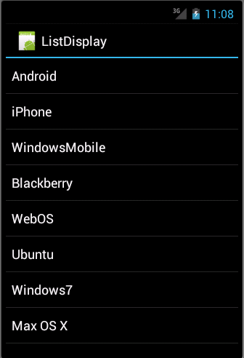

**List View**

An adapter actually bridges between UI components and the data source that fill data into UI Component. Adapter holds the data and send the data to adapter view, the view can takes the data from adapter view and shows the data on different views like as spinner, list view, grid view etc.

The **ListView** and **GridView** are subclasses of **AdapterView** and they can be populated by binding them to an **Adapter**, which retrieves data from an external source and creates a View that represents each data entry.

Android provides several subclasses of Adapter that are useful for retrieving different kinds of data and building views for an AdapterView ( i.e. ListView or GridView). The common adapters are **ArrayAdapter**,**Base Adapter**,**CursorAdapter**,**SimpleCursorAdapter**,**SpinnerAdapter** and **WrapperListAdapter**. We will see separate examples for both the adapters.

**ArrayAdapter**

You can use this adapter when your data source is an array. By default, ArrayAdapter creates a view for each array item by calling toString() on each item and placing the contents in a **TextView**. Consider you have an array of strings you want to display in a ListView, initialize a new **ArrayAdapter** using a constructor to specify the layout for each string and the string array −

ArrayAdapter adapter = new ArrayAdapter<String>(this,R.layout.ListView,StringArray);

Here are arguments for this constructor −

* First argument **this** is the application context. Most of the case, keep it **this**.
* Second argument will be layout defined in XML file and having **TextView** for each string in the array.
* Final argument is an array of strings which will be populated in the text view.

Once you have array adapter created, then simply call **setAdapter()** on your **ListView** object as follows −

ListView listView = (ListView) findViewById(R.id.listview);

listView.setAdapter(adapter);

You will define your list view under res/layout directory in an XML file. For our example we are going to using activity_main.xml file.